Monday Week 4 Menu

**Breakfast**

Selection of Cereals, Toast, Jam, Marmalade, Porridge

Hot Choice of the Day

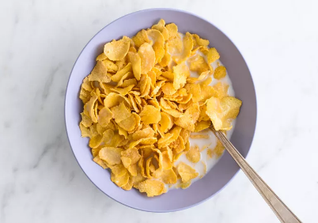 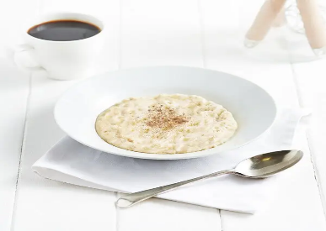

**Lunch**

Cottage Pie with Carrots, White Cabbage and Creamed Potato

or Chicken Curry and Rice

Eves Pudding and Custard

**Tea**

Egg & chips or

tomato Soup and Sandwiches

mousse or fresh fruit, yoghurt

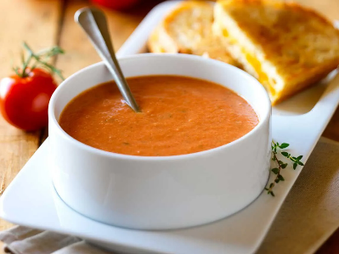

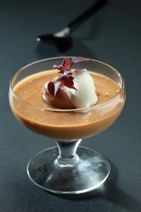

Tuesday Week 4 Menu

**Breakfast**

Selection of Cereals, Toast, Jam, Marmalade, Porridge

Hot Choice of the Day

**Lunch**

Steak and Dumplings or Sausage Pie

With Swede, Brussel Sprouts, Roast and Creamed Potatoes

Syrup Sponge with Custard

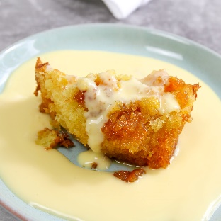

**Tea**

Corned beef hash or

Homemade mushroom Soup and Sandwiches

Chocolate eclair or Fresh Fruit or Yoghurt

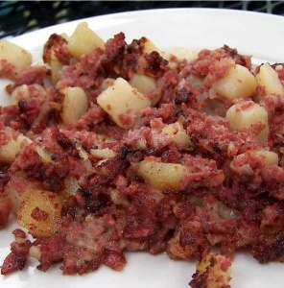 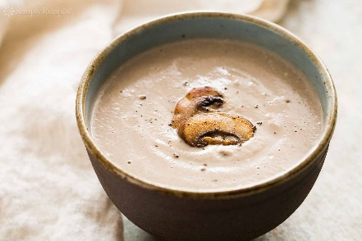

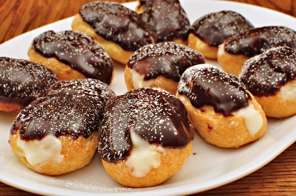

Wednesday Week 4 Menu

**Breakfast**

Selection of Cereals, Toast, Jam, Marmalade, Porridge

Hot Choice of the Day

**Lunch**

Gammon and Peas Pudding or Cornish Pastie

with Carrots, Green Beans and Baby Potatoes

Peach Crumble and Custard

**Tea**

Fish fingers & Chips or

Home Made Butternut squash Soup and Sandwich Selection

Fruit Jelly or yogurt

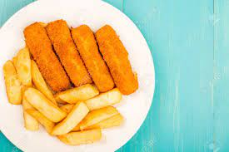 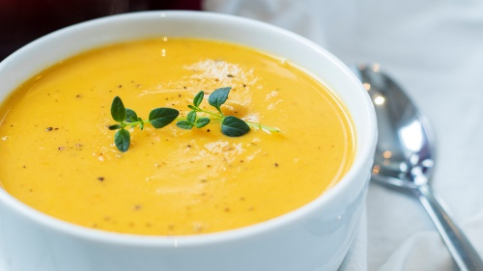

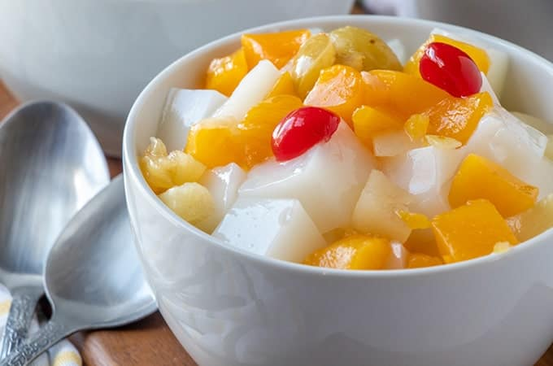

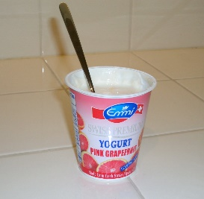

Thursday Week 4 Menu

**Breakfast**

Selection of Cereals, Toast, Jam, Marmalade, Porridge

Hot Choice of the Day

**Lunch**

Pork Casserole with Savoy Cabbage, mixed vegetables and Cream Potatoes

or spaghetti bolognese

Rice Pudding

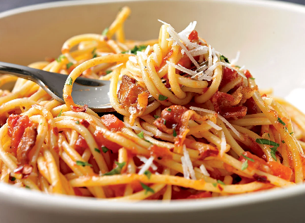

**Tea**

Kippers and Bread and Butter or

Home Made bacon and lentil Soup and Sandwich Selection

Peach meringues or Fresh Fruit

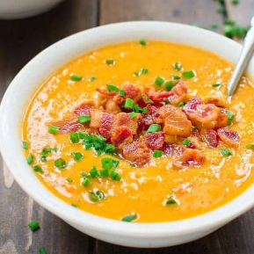

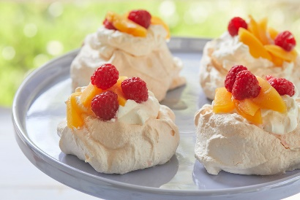

Friday Week 4 Menu

**Breakfast**

Selection of Cereals, Toast, Jam, Marmalade, Porridge

Hot Choice of the Day

**Lunch**

Cod Bites or Battered Sausage with Mushy Peas, Chips or Creamed Potatoes

Ginger Sponge and Custard

**Tea**

Cheese on toast or

Home Made Vegetable Soup and Sandwich Selection

Banana Mousse or Fresh Fruit

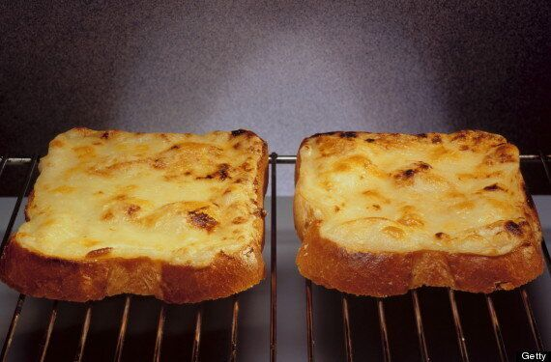

Saturday Week 4 Menu

**Breakfast**

Selection of Cereals, Toast, Jam, Marmalade, Porridge

Hot Choice of the Day

**Lunch**

Home Made Corned Beef & Potato Pie or Cheese & Tomato Quiche

with Carrot Batons, Garden Peas, Sauté and Creamed Potato

Jam Sponge & Custard

**Tea**

Burger in Buns or

Cream of carrot & coriander Soup and Sandwich Selection

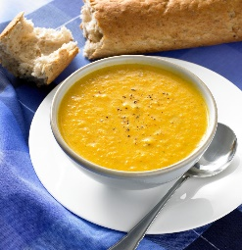Cakes or Fresh Fruit

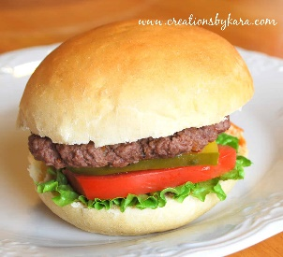

Sunday Week 4 Menu

**Breakfast**

Selection of Cereals, Toast, Jam, Marmalade, Porridge

Hot Choice of the Day

**Lunch**

Roast Chicken and Stuffing with Yorkshire Pudding

with Creamed and Roast Potatoes, Broccoli, Swede

or Cold Meat Salad

trifle

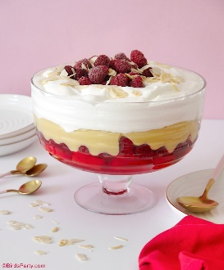

**Tea**

Buffet Tea or pe, Cake and Sandwich Selection

Fresh Fruit

