Monday Week 3 Menu

**Breakfast**

Selection of Cereals, Toast, Jam, Marmalade, Porridge

Hot Choice of the Day

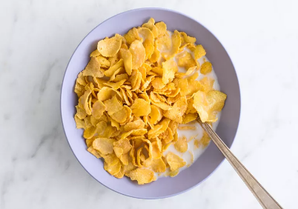 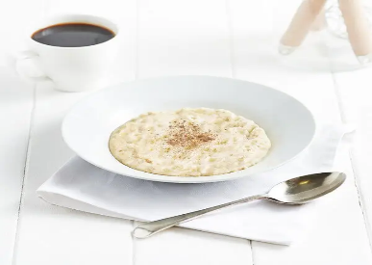

**Lunch**

Pork Casserole or Cheese bake

With Carrots, Garden Peas, Sauté Potato and Creamed Potato

Apple Crumble with Custard

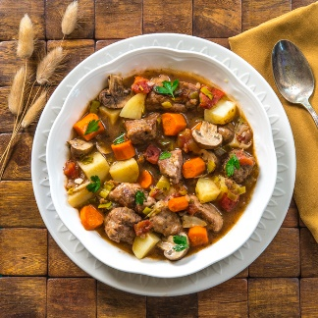 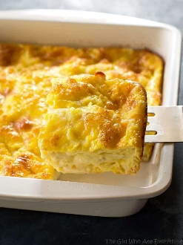

**Tea**

Hot beef sandwiches with chips or

Cream of Carrot & Coriander Soup and Sandwiches

Black forest mousse or Fresh Fruit

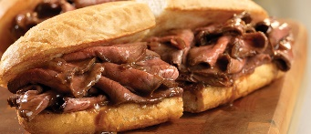 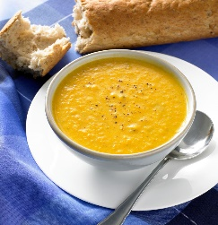

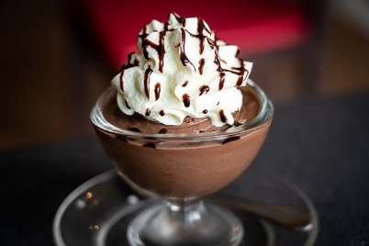**

Tuesday Week 3 Menu

**Breakfast**

Selection of Cereals, Toast, Jam, Marmalade, Porridge

Hot Choice of the Day

**Lunch**

Salmon fishcake or Chicken and vegetable pie

With Swede, Brussel Sprouts, Creamed Potatoes

Semolina

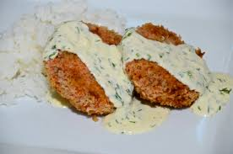

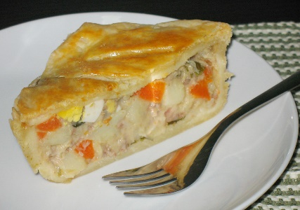

**Tea**

Jacket potatoes

Homemade tomato Soup and Sandwiches

Cream scones or Fresh Fruit or Yoghurt

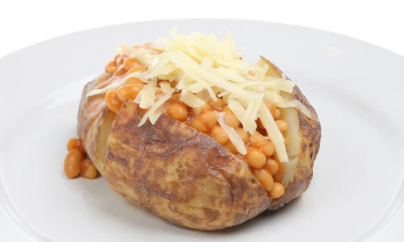 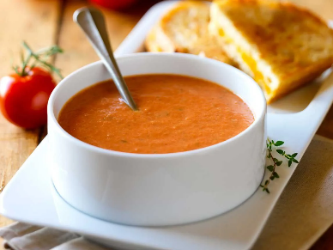

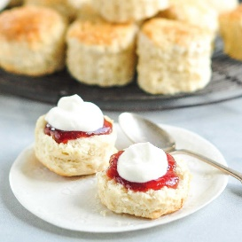**

Wednesday Week 3 Menu

**Breakfast**

Selection of Cereals, Toast, Jam, Marmalade, Porridge

Hot Choice of the Day

**Lunch**

Mince & Dumplings or Poached Cod

with Broccoli & mixed vegetables and Cream Potatoes

Lemon Sponge and Custard

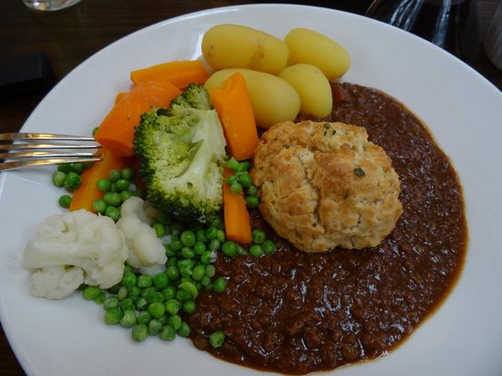

**Tea**

Egg with Chips or

Home Made lentil Soup and Sandwich Selection

Raspberry Ripple Ice Cream Sponge or Fresh Fruit

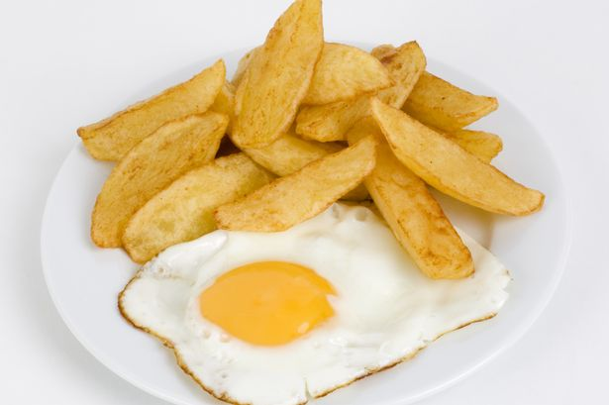 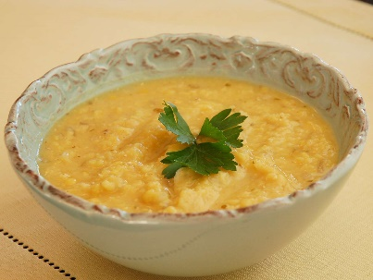

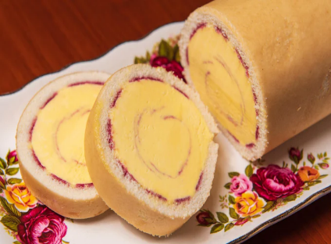

Thursday Week 3 Menu

**Breakfast**

Selection of Cereals, Toast, Jam, Marmalade, Porridge

Hot Choice of the Day

**Lunch**

Home Made Steak & Kidney Pie With Creamed Potatoes, Carrots Savoy Cabbage

or chicken curry & rice

Jam Roly Poly and Custard

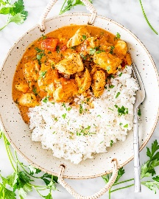

**Tea**

Toasted tea cakes or

Cream of Mushroom Soup and Sandwich Selection

Peach Meringues or Fresh Fruit

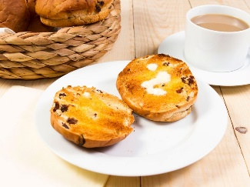 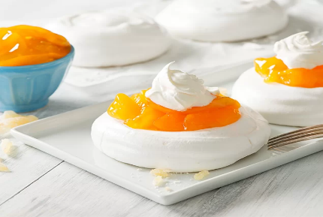

Friday Week 3 Menu

**Breakfast**

Selection of Cereals, Toast, Jam, Marmalade, Porridge

Hot Choice of the Day

**Lunch**

Cod Bites or Cheese Pattie

with Chips or Cream potatoes and Mushy Peas

sponge and custard

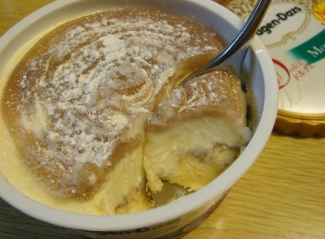

**Tea**

Omelette and side salad or

Home Made chicken Soup and Sandwich Selection

Jam tarts or Fresh Fruit

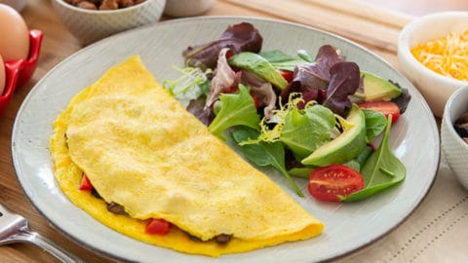 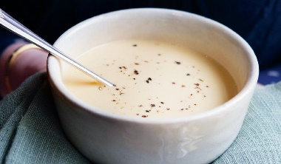

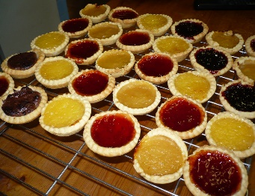

Saturday Week 3 Menu

**Breakfast**

Selection of Cereals, Toast, Jam, Marmalade, Porridge

Hot Choice of the Day

**Lunch**

Sausage in onion gravy or Liver & Onions

with Creamed Potatoes, Carrots, White Cabbage

Syrup Sponge with Custard

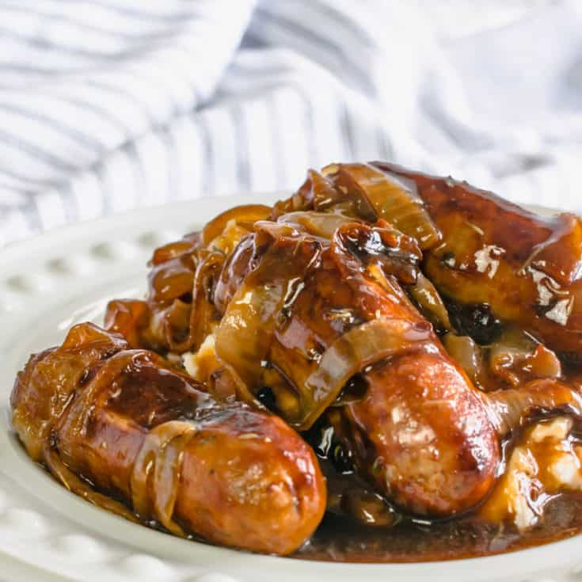

**Tea**

Spaghetti on Toast or

Home Made Vegetable Soup and Sandwich Selection

Chocolate teacakes and Cream or Fresh Fruit

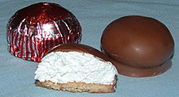

Sunday Week 3 Menu

**Breakfast**

Selection of Cereals, Toast, Jam, Marmalade, Porridge

Hot Choice of the Day

**Lunch**

Roast Pork and stuffing with Yorkshire Pudding

with Creamed and Roast Potatoes, broccoli , Swede

or Cold Meat Salad

trifle

**Tea**

Buffet Tea or Pie, Cake and Sandwich Selection

Fresh Fruit

