Monday Week 2 Menu

**Breakfast**

Selection of Cereals, Toast, Jam, Marmalade, Porridge

Hot Choice of the Day

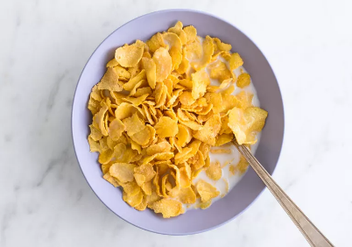 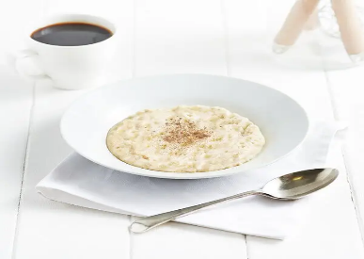

**Lunch**

Gammon and Pineapple or Corned Beef Hot Pot

with Carrots, peas and Baby or Creamed Potatoes

Jam Sponge and Custard

**Tea**

Egg and chips or

Homemade Tomato Soup and Sandwiches

Cheese Cake or Fresh Fruit

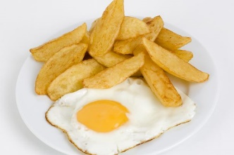

Tuesday Week 2 Menu

**Breakfast**

Selection of Cereals, Toast, Jam, Marmalade, Porridge

Hot Choice of the Day

**Lunch**

Mince Cobbler or Chicken curry & Rice

With Swede, Brussel Sprouts, Creamed Potatoes

Pineapple Upside Down Cake and Custard

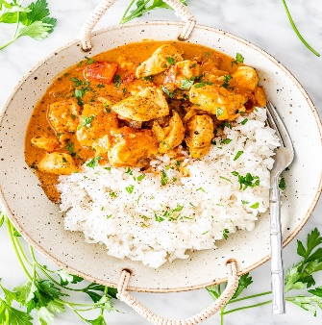

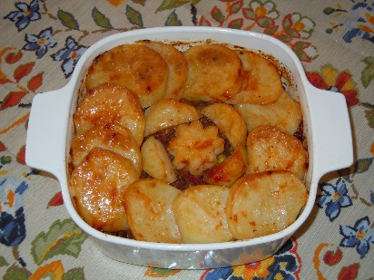

**Tea**

Cheese on Toast

Homemade Broth and Sandwiches

Mini Rolls, fruit or yogurt

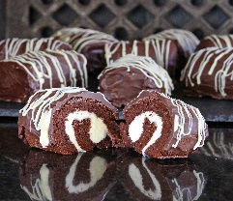

Wednesday Week 2 Menu

**Breakfast**

Selection of Cereals, Toast, Jam, Marmalade, Porridge

Hot Choice of the Day

**Lunch**

Roast Chicken and Stuffing With

Savoy Cabbage, Carrots and Creamed Potatoes

or Cold Meat Salad

Chocolate Sponge & Custard

**Tea**

Scampi & Chips or

Home Made Broth and Sandwich Selection

Fruit, Jelly and Cream or Fresh Fruit

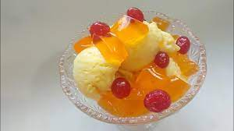

Thursday Week 2 Menu

**Breakfast**

Selection of Cereals, Toast, Jam, Marmalade, Porridge

Hot Choice of the Day

**Lunch**

Braised Steak Stew with Swede, cabbage and Creamed Potatoes

or spaghetti bolognaise

Plum Crumble and Custard

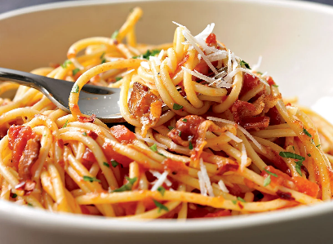

**Tea**

Sausage roll & Beans or

Home Made butternut squash and Sandwich Selection

Cream Cakes

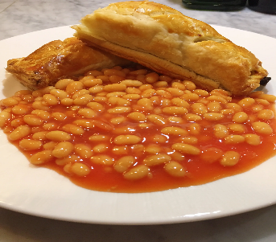 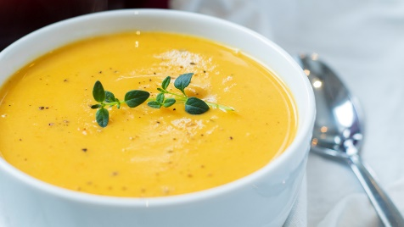

Friday Week 2 Menu

**Breakfast**

Selection of Cereals, Toast, Jam, Marmalade, Porridge

Hot Choice of the Day

**Lunch**

Cod Bites or Battered Sausage with Chips, Mushy Peas or

Cream potatoes, bread and butter

Ginger Sponge and Vanilla Sauce

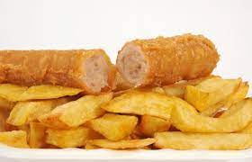

**Tea**

Bacon, scrambled egg & tomatoes or

Home Made vegetable Soup and Sandwich Selection

Frozen mousse or Fresh Fruit

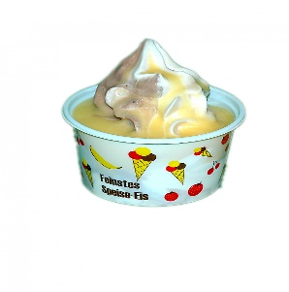 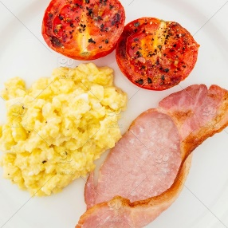 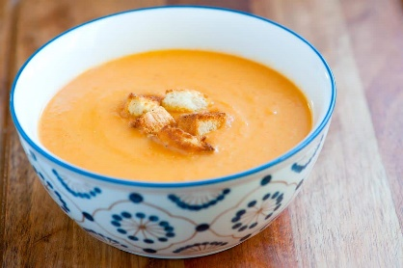

Saturday Week 2 Menu

**Breakfast**

Selection of Cereals, Toast, Jam, Marmalade, Porridge

Hot Choice of the Day

**Lunch**

Chicken & Casserole or Cornish Pasty

with Creamed Potatoes, Baton Carrots, Peas

Home Made Rice Pudding

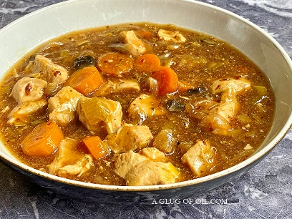

**Tea**

Sausage & Fried Onion in a Bun

Leek & Potato Soup and Sandwich Selection

cake or Fresh Fruit

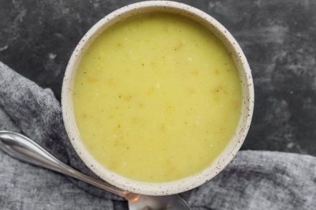

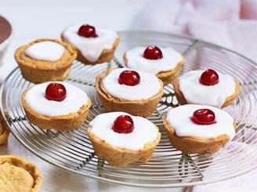

Sunday Week 2 Menu

**Breakfast**

Selection of Cereals, Toast, Jam, Marmalade, Porridge

Hot Choice of the Day

**Lunch**

Roast Beef with Yorkshire Pudding

with Roast and Baby Potatoes, Broccoli, Swede

or Cold Meat Salad

trifle

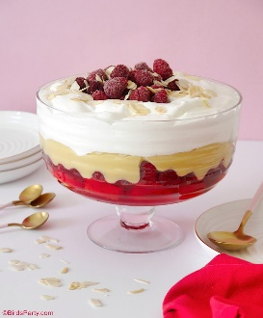

**Tea**

Buffet Tea or Sandwich, Pie and Cake Selection

Fresh Fruit

